**Labview Database Interface**

CCLDAS HDF5 data files are generated by the Labview program Query_Dust_Event.vi. This program retrieves datasets from CCLDAS’ SQL database based on time, group, and experiment name constraints. Once a dataset has been retrieved, the ***Save To File*** button writes the data to a .HDF5 file that can be used for data analysis in programs like IDL.

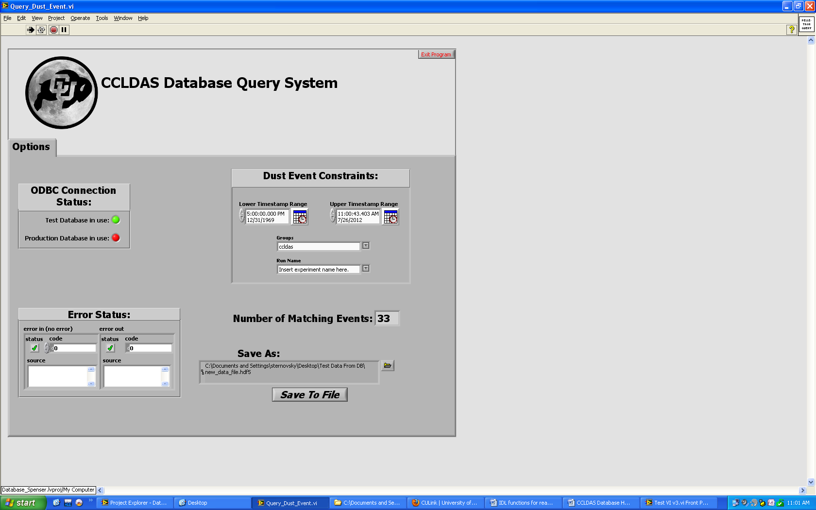

**CCLDAS Format For .HDF5 Files**

Data in the .HDF5 files generated by the CCLDAS database are structured into groups identified by the associated unique database ID# for each recorded dust event. Each group contains all the signal data for a given dust event, and contains metadata for the dust event as group attributes. Metadata attributes include data about pelletron settings (Chain Current, lost charge, column current, control high voltage, high voltage control difference, high voltage, + high voltage, - high voltage, radiation, and vacuum pressure), dust event data (dust event timestamp, estimated velocity, estimated mass, estimated charge, estimated size, and whether or not the dust particle passed the 3rd detector), and experiment settings (group ID, experiment name, and experiment description). An example of attributes entry is shown below:

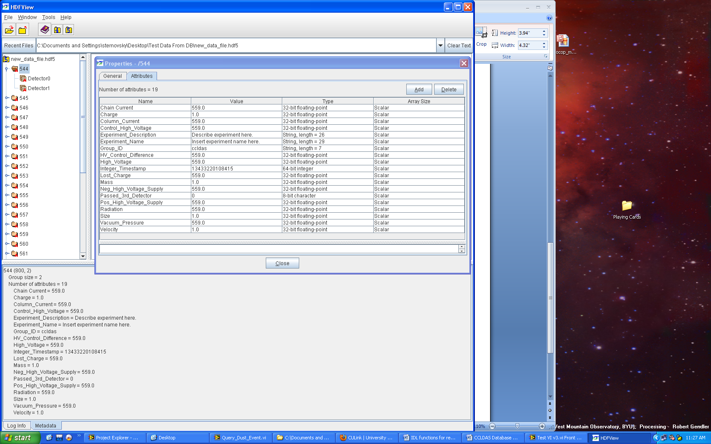

Waveforms are stored as datasets and have metadata attributes that include a hardware ID#, an offset value, a signal length value, and a dt value. An example is shown below:

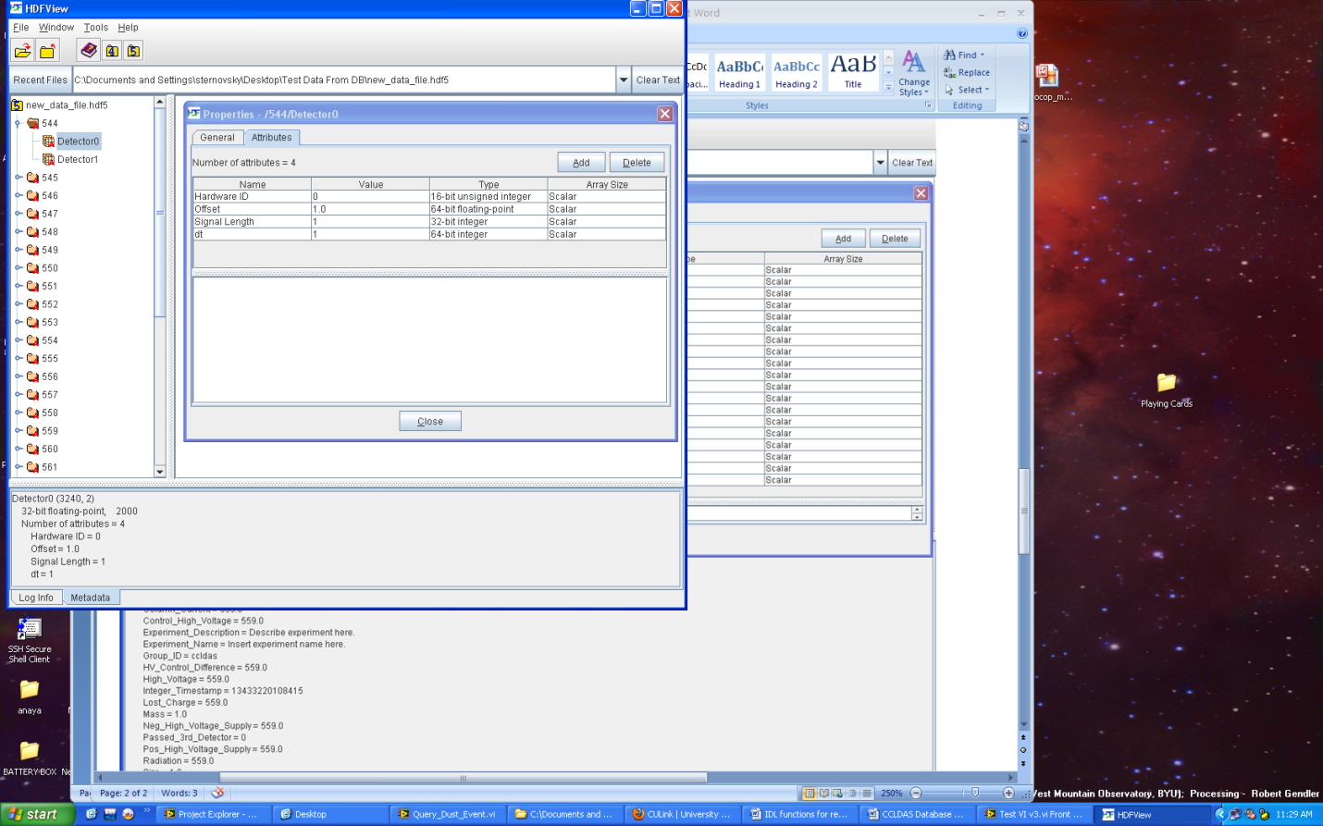

This format can then be used to interface with IDL or other common data analysis programs.